

**CSIS 3003**

**PROJECT I**

**Activities Management System**

**(Report)**

**Foong Chin Wei(D170274B)**

**Lee Yi Sheng (D170286B)**

**Lew Zhan Fai (D170360B)**

**Lecturer: Mr. So Yong Quay**

**29th June 2018**

**Department of Computer Science**

**Faculty of Engineering and Information Technology**

**Table of Contents**

1.Introduction …………………………………………………………………… 3

2.Objective …………………………………………………………………….... 4

3.Background Research ………………………………………………………… 5

4.Literature Review ………………………………………………………..... 6 - 8

5.Research ………………………………………………………………….. 9 - 10

6.A financial justification for project ………………………………………….. 11

7.Curriculum Vitae ……………………………………………………….... 12-14

8.An outline of duties of each member for each stage ………………….... 15 - 16

9.Project Scope …………………………………………………………..…..... 17

10.Methodology ………………………………………………………..…........ 18

11.Project Plan …………………………………………………………..…….. 19

12.Data Flow Diagram ……………………………………………………........ 20  
 12.1 Context Level Diagram ……………………………………………...... 20  
 12.2 Diagram 0 DFD for Activity Management System ............................... 21  
 12.3 DFD Diagram 1……………………..................................................... 22

13.Entity Relationship Diagram ........................................................................ 25

14. Class Diagram .............................................................................................. 26

15. Use Case diagram ......................................................................................... 27  
 15.1 Login System ........................................................................................ 27  
 15.2 Activity System .................................................................................... 27  
 15.3 Payment System ................................................................................... 28

16. Use case description ..................................................................................... 29  
 16.1 Login System ........................................................................................ 29-30  
 16.2 Activity System .................................................................................... 31-35  
 16.3 Payment System ................................................................................... 36-40

17. Activity Diagram .......................................................................................... 41  
 17.1 Login System ........................................................................................ 41  
 17.2 Activity System .................................................................................... 42  
 17.3 Payment System ................................................................................... 43

18. Sequence Diagram ........................................................................................ 44  
 18.1 Login System ........................................................................................ 44-45  
 18.2 Activity System ..................................................................................... 46-47  
 18.3 Payment System .................................................................................... 48-49

19.0 System Catalog …........................................................................................ 50

20. User Guide  
 20.1 Index page ............................................................................................ 52  
 20.2 Login System ....................................................................................... 52  
 20.3 Register ................................................................................................ 53  
 20.4 Create activity page ............................................................................. 54  
 20.5 Admin page ......................................................................................... 55  
 20.6 Category page ..................................................................................... 56  
 20.7 Feedback page .................................................................................... 57  
 20.8 About us page ..................................................................................... 58

21. References ……………………………………………………………….... 59

**1.Introduction**

Nowadays ICT has been developed into high technology era, the rapid development of social network, even if people do not meet each other also can become friends.Social networks have become quite common, most people use Facebook, Twitter, Google+, and so on to making friends and take part in some activities.

People can take part in activities by informed of school or friends, but we decided to use the rapid development of social network to make a website.

Our project title is Activities Management System, which creates a platform in website to let the organizer to upload their activities such as competition, seminar , camp and etc.So that the participant can also browse to our website to look up what activities are holding and take part in the activities on the spot on the website. The participant also can click on the organizer page to look up what activities there had held.

**2.Project Objective**

By developing this project we can achieve the objective below:

* When the participant take part in an event there can communicate with other participant and increase people’s social network
* The website provide a platform to let the organizer spread out the information of activities and which increase the speed of information flow
* The participant can keep in touch of the activities that organize from some company and improve the reputation of company or organizer
* The website provide a platform to let the participant easier to find their favourite activities

Personal Objective

We choose the topic because we would like to try to develop a website system. This is big challenge to us, because website with system is our first project. Of cause,we also hope through this project to enhanced our HTML and PHP skills.

**3.Background Research**

**Bizzabo**



**Bizzabo** does everything aside from serving you tea. This is a fully fledged platform that allows you to manage every aspect, at every stage of the event planning: Create a landing page, sell tickets, email attendees and run reports at the end of it all. (BIZZABO, 2018)

**Bizzabo** is the world's fastest growing event tech company. Our holistic Events Cloud empowers marketers and planners to manage, grow and maximize events. (BIZZABO, 2018)

Bizzabo is a customer relationship management platform in the United States, which is committed to simplifying the process of marketing activities by promoting automation in all aspects. Users can create their own marketing messages, schedules, and registration sites to track user interactions, ticket receipts, and attendance.

One of the problems, email integration is not as extensive as it could be and some users have experienced problems at the time of sending messages. We will try to improve this problem.

**4.Literature Review**

In this part, I am going to explore the research related to my project that have been conducted by other academic previously. Activities management system is web system which comprises PHP, MySQL and Web service. Web system is a kind of website with a system.

In a typical organization, there's always plenty that to do such as: pay vendors, invoice customers, answer customer inquiries, and fix bugs in hardware or software. You need to know who wants what and keep track of what is left to do.

A ticketing system allows you to check the status of various tasks: when they were requested, who requested them and why, when they were completed, and etc. A ticketing system need to include register an event or a ticket, assign an organizer and participant to the ticket, track change to the ticket, launch activity based on ticket status , and lastly close the ticket.Besides that,the system have to add on the function of deletions , customer service , network security.

In the deletions,Deletion may be primarily a manual process, so that people will use it rarely. The prime intention here is to maintain a history of events and the current status, and never to lose it.In the function of customer service, Tracking the request ensures the company has a record of what types of queries are most common. This also can give the company instant feedback on whether or not their users find the published documentation or processes hard to understand, merely sufficient, or easy to follow.Lastly with the network security, if a system is compromised by a security breach, this event can be entered and tracked as a ticket, and an alert can be sent to the appropriate parties. People responsible for the hardware, the software, the administration, the firewall, the proxy, or the Internet access can be assigned as interested parties to the ticket.

This is importance to make sure that the website is accessibility, ease of use, access control ,ability to track history, immutable history and flexible views.(RT Essential)

The core function of an IT ticketing system is to manage all incoming requests from other departments in a company. Because IT departments tend to have a high volume of requests, they need a system to manage the life cycle of every individual request, from submission to resolution. There are several online programs that provide services to accomplish this, from simple intake software to more sophisticated tools that triage and track issues. We’ll take a look at the variety of these functions later on.

Sometimes, the IT department also doubles as a customer support center or help desk, and may be staffed by technicians who help people outside the company - typically customers or other product users - to resolve their technical issues. Regardless of whether the ticketing system will manage external or internal requests, the program should perform similarly.

Same as the RT Essential,ticketing system have to add on the function of self service portal, ticket log, assigning tickets, secure of the system and live support.Self service portal means that A one-stop shop where workers and customers can quickly and easily submit their tickets to our system.Beside that, ticket log means that once a ticket is received, the next step is to log it. This could be as simple as a spreadsheet that lists incoming tickets by timestamp, but the important thing is that IT has an organizational system in place so that no ticket gets overlooked.Assigning tickets means to maximize the IT team’s bandwidth, tickets should be assigned to a single “owner” who will work on the ticket from start to finish. You can choose to manually assign tickets to team members, or find a product that automatically assigns tickets based on worker availability or appropriate knowledge base.About the secure system, security should be a top priority when choosing an IT ticketing system, even if tickets do not contain sensitive information.Regardless of the level of security necessitated by our techniques, we will look for a secure system to ensure that information does not get leaked to the public.Lastly,with the live support, having a 24/7-staffed help desk or chat service can also help increase transparency and drive customer engagement with the IT department. We can use this assistance tool to troubleshoot technical issues before formally submitting a ticket, as to cut down the volume of tickets IT must process.

There are some points of company growth that might naturally lend themselves to an IT ticketing system change. Shifts in management, new product features, or high team turnover all may present opportunities to make a switch that does not disrupt the rest of business. Of course, we will make sure that our ticketing system shift responds to the specific demands of us - features can lose their utility if they aren’t tailored to our needs.  (RT Essentials,2005)

**5.Research**

**HTML**

HTML is known as Hypertext Markup Language. HTML is a set of markup symbols and codes in a file intended to display on a World Wide Web browser page. The markup is duty on tells the Web browser display a Web page’s words and images. Each markup code is referred to as an element. Some of the elements come in pairs that indicate when some display effect is to begin and when it is to end.( HTML)

**PHP**

PHP stands for Hypertext Preprocessor. Before that, PHP originally derived from Personal Home Page Tools. PHP is a script language and interpreter that is used to create Web pages. PHP is an open source program and used primarily on Linux Web servers. PHP executes on the server, while a comparable alternative, JavaScript, executes on the client. The Web server calls PHP to interpret and perform the operations in the PHP script before the page is sent to a user that has requested it. (PHP)

**MySQL**

MySQL is an open source relational database management system (RDBMS) based on Structured Query Language (SQL). A database is a structured collection of data, it may be anything from a simple shopping list to a picture gallery of the large amount of information in a corporate network. A database management system is needed to add, access, and process data stored in a computer database. MySQL runs on virtually all platforms, such as Linux, UNIX, and Windows. (MySQL)

**Web Service**

Web services also called application services are services that made available from a business Web server for Web users or other Web-connected programs. Web services usually combine with programming of data, and also human resources as well. Providers of Web service s are generally known as application service providers. Web service range from such major services as storage management and customer relationship management (CRM) down to much more limited services such as the furnishing of a stock quote and the checking of bids of an auction item. The accelerating creation and availability of these services is a major Web trend. (Web Service**)**

**6. A financial justification for project**

The estimated net cash flow for our design of the Activities Management

System is approximately RM2,000. We will use this money to purchase software for

designing the Activities Management System. Example, Domain Name (website

domain name is the unique name that appears in the URL for our website), Website

Hosting (Hosting is simply the service that allows your website to be accessed by other Internet users), PHP, Web Service, Copywriting.

|  |  |
| --- | --- |
| **Software** | **cost** |
| Domain Name | RM40 |
| Website Hosting | RM800 |
| PHP | RM0 |
| Web service | RM400 |
| Copywriting | RM200 |
| **Total Cost =** | RM1440 |

**7. Curriculum Vitae**

****Name: Foong Chin Wei

Age: 19

Nationality: Malaysian

Gender: Male

I/C: 990414-08-9611

Address: No21, Jalan Harmonium 22/17,  
 Tamen Desa

Tebrau, Johor Bahru, Johor.

H/P number: 018-6625420

Student ID: D170274B

Batch: IT17-B

Email: [Chinwei9611@gmail.com](mailto:Chinwei9611@gmail.com)

Education Qualifications :

|  |  |  |
| --- | --- | --- |
| **Name of Institution** | **From - To** | **Highest qualification Attained** |
| SJK (C) Tampoi | 2006 - 2011 | UPSR |
| SMK Dato’Usman Awang | 2012 - 2016 | SPM |

Ability Skill : HTML

Java Programming

Adobe Photoshop  
 PHP

Language : (Proficiency : Best = 10 ~ Worst = 1)

|  |  |
| --- | --- |
| **Language** | **Proficiency** |
| English | 7 |
| Bahasa Melayu | 7 |
| Mandarin | 9 |
| Hakka | 9 |

Possess own transport : No

****Name: Lee Yi Sheng

Age: 19

Nationality: Malaysian

Gender: Male

I/C: 990613-01-5017

Address: No21, Jalan Harmonium 22/17,  
 Tamen Desa

Tebrau, Johor Bahru, Johor.

H/P number: 019-719 1889

Student ID: D170286B

Batch : IT17-B

Email: [leonlionko@gmail.com](mailto:leonlionko@gmail.com)

Education Qualifications :

|  |  |  |
| --- | --- | --- |
| **Name of Institution** | **From - To** | **Highest qualification Attained** |
| SJK (C) Foon Yew 5 | 2006 - 2011 | UPSR |
| SMK Taman Desa Tebrau | 2012 - 2016 | SPM |

Ability Skill : HTML

Java Programming

Adobe Photoshop  
 PHP

Language : (Proficiency : Best = 10 ~ Worst = 1)

|  |  |
| --- | --- |
| **Language** | **Proficiency** |
| English | 5 |
| Bahasa Melayu | 4 |
| Mandarin | 6 |
| Japanese | 2 |

Possess own transport : No

  Name: Lew Zhan Fai

Age: 19

Nationality: Malaysian

Gender: Male

I/C No: 991130-01-5551

Address: No 10, Jalan Tombak 4,  
 Taman Sri Tebrau,80050,  
 Johor Bahru, Johor

H/P No: 018-9553792

Student ID: D170360B

Class : IT-17B

E-mail: faifai_1130@hotmail.com

Educational Qualification :

|  |  |  |
| --- | --- | --- |
| **Name of Institution** | **From - To** | **Highest Qualification Attained** |
| SJK(C) Foon Yew 1 | 2006 - 2011 | UPSR |
| SMK Taman Sri Tebrau | 2012 - 2016 | SPM |

Ability skills : HTML

Java Programming

Adobe Photoshop  
 PHP

Language : (Proficiency: Best = 10, Worst = 1)

|  |  |
| --- | --- |
| **Language** | **Proficiency** |
| Bahasa Malaysia | 6 |
| English | 5 |
| Mandarin | 7 |
| Japanese | 3 |

Process Own Transport : No

|  |  |  |
| --- | --- | --- |
| **Foong Chin Wei** | **Lew Zhan Fai** | **Lee Yi Sheng** |
| **Project topic and title**  **-**According the content of our project, we decided the project name as ‘Activity Management System’. | **Background research**  -We search some of the website as research such as concert website, seminar website, competition website because we want to combine all of these ideas inside our website. | **Research**  -We will build a website with the web-based system, internet application, JavaScript, PHP. |
| **Rationale for project choice**  **-**First of all, we discuss to design a apps about sleeping but reject by supervisor because of the apps have no marketing value. For example, the apps inside HUAWEI and SAMSUNG have better function such as sleeping rate, exercise rate and else.  -After that, we discuss a new idea about managing the activity in website. The system is more about organizer can post their activity or event in the website and participant can browse the website and choose the activity to attend | **A financial justification for project**  **-** I wrote about the cost and the price of the software we needed to run this project. I still have a table to see where we're going to spend our money. | **Project Scope**  -draw a use case diagram for activity management system and explain how the system works and every statement for each character. |
| **Literature review**  **--** I read two books in which I learned how to plan our project and strengthen our project. Also write my opinion on these two books. | **Project Plan**  **-** I made a Gantt chart set us a time to finish our final project 1 before due date. | **Methodology**  **-**I draw a iterative life cycle model and explain the meaning for each phases in sequence. |
| **Curriculum Vitae**  **--**Fill in my information | **Curriculum Vitae**  **-**Fill in my information | **Curriculum Vitae**  **-**Fill in my information |

**8.An outline of the duties of each member for each stage.**

**9. Project Scope**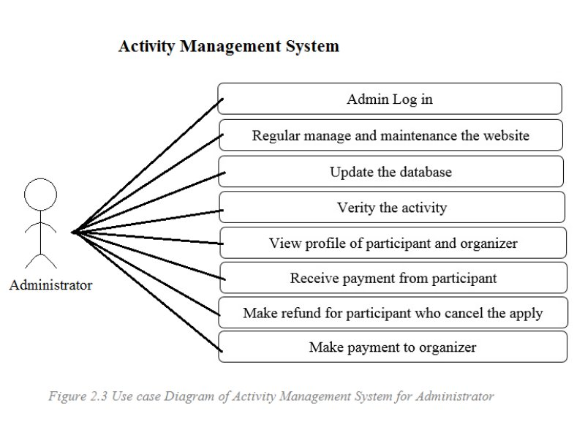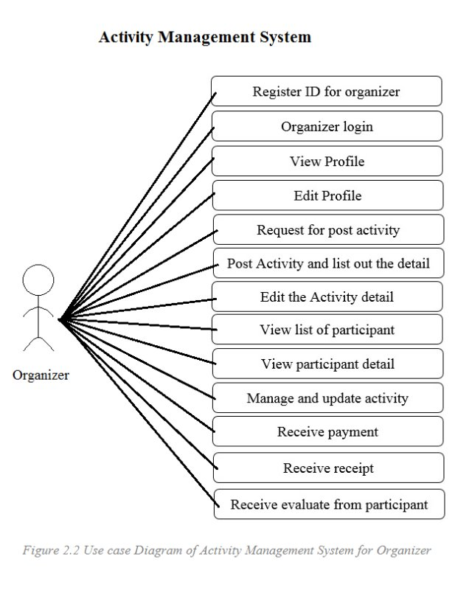

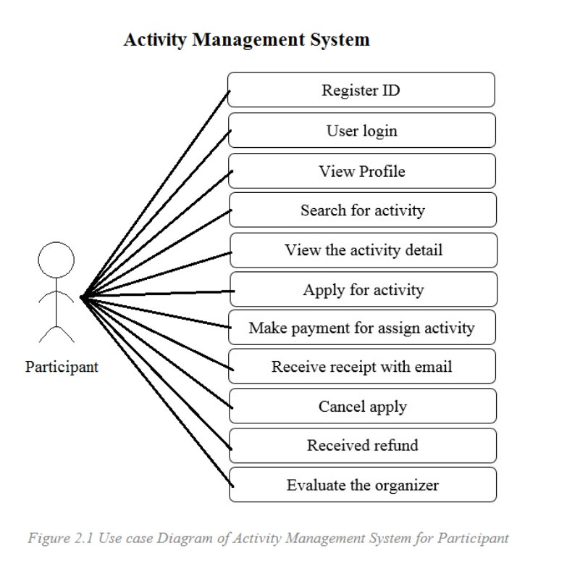

Activity Management System is designed on website due to base on the user requirement, website is included on almost all devices in the market. Based on the statistics and the analysis in the market, we found that it is a norm that users were difficult on searching for activities and organizer have difficult on publicize the activities. These problems cause that activities had obviously decrease on statistical table. Thus, Activity Management System provides help on solving these problems.

First of all, organizers need to log in for post their activities or events on our website. They can edit or update the detail after posting. Users also require to log in before searching for activities or events that posted by organizers. If the users found the activities they want, users can apply for that activities and make payment. Users can also cancel the apply they make and take back the payment before the apply deadline. The organizers will take their payment after the apply deadline.

**10. Methodology**

In the iterative model does not begin with completely requirements for software developed. The development specifying and implementing with just a part of software as a begin, and complete the system with feedback for determining the final requirements. With repeated this process to produce a new version of the software. Programmer can demonstrate results of the process early and receive feedback from users to improve the efficiency. (Iterative Model,2017)

The Iterative model is show in Figure 1 below.

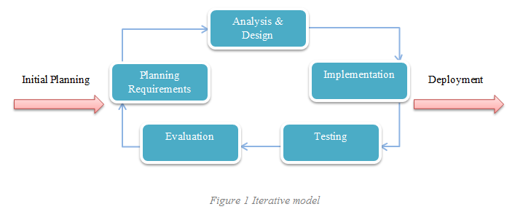

Consider an iterative life cycle model which consists of repeating the following four phases in sequence:

1. **Requirements –** The requirements for the software are gathered and analysed. Iteration should final result in requirements phase that produces a complete specification of requirements.
2. **Design –** A software solution to meet the requirements is designed. The design may contain previous design or new design to match the software development.
3. **Implementation and Test –** For implementation phase, the researcher performed the actual coding, integrate the software, and testing phase start from the scratch.
4. **Review –** After the software is evaluated, the current requirements are reviewed, and changes and additions to requirements proposed.

**11. Project Plan**

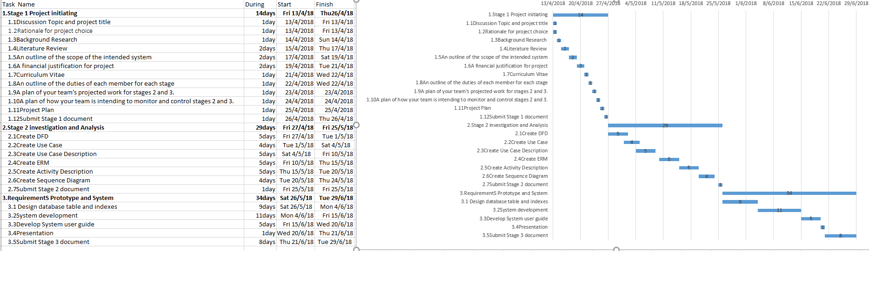

**12.0 Data Flow Diagram**

**12.1 Context Level Diagram**

**Activity Management System**

**Context**

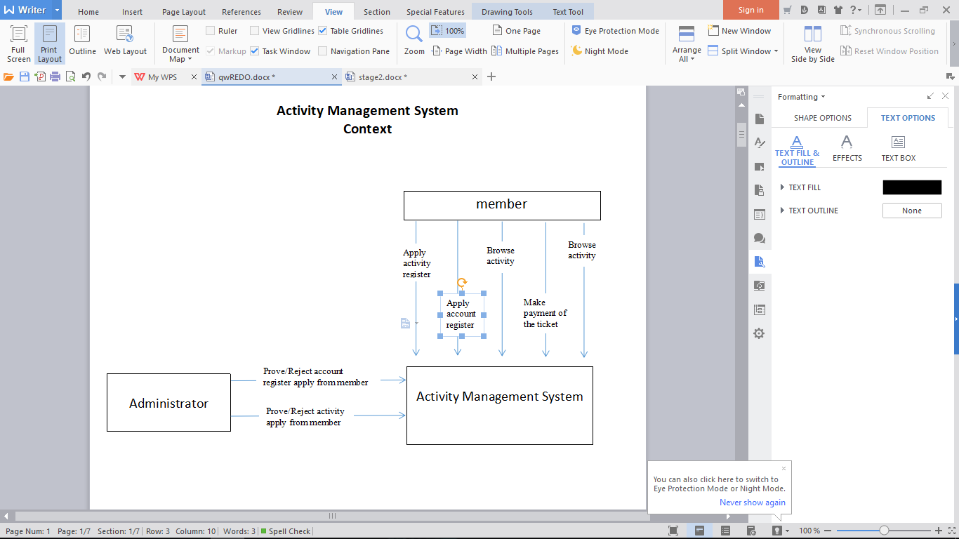

**12.2** Diagram 0 DFD for Activity Management System

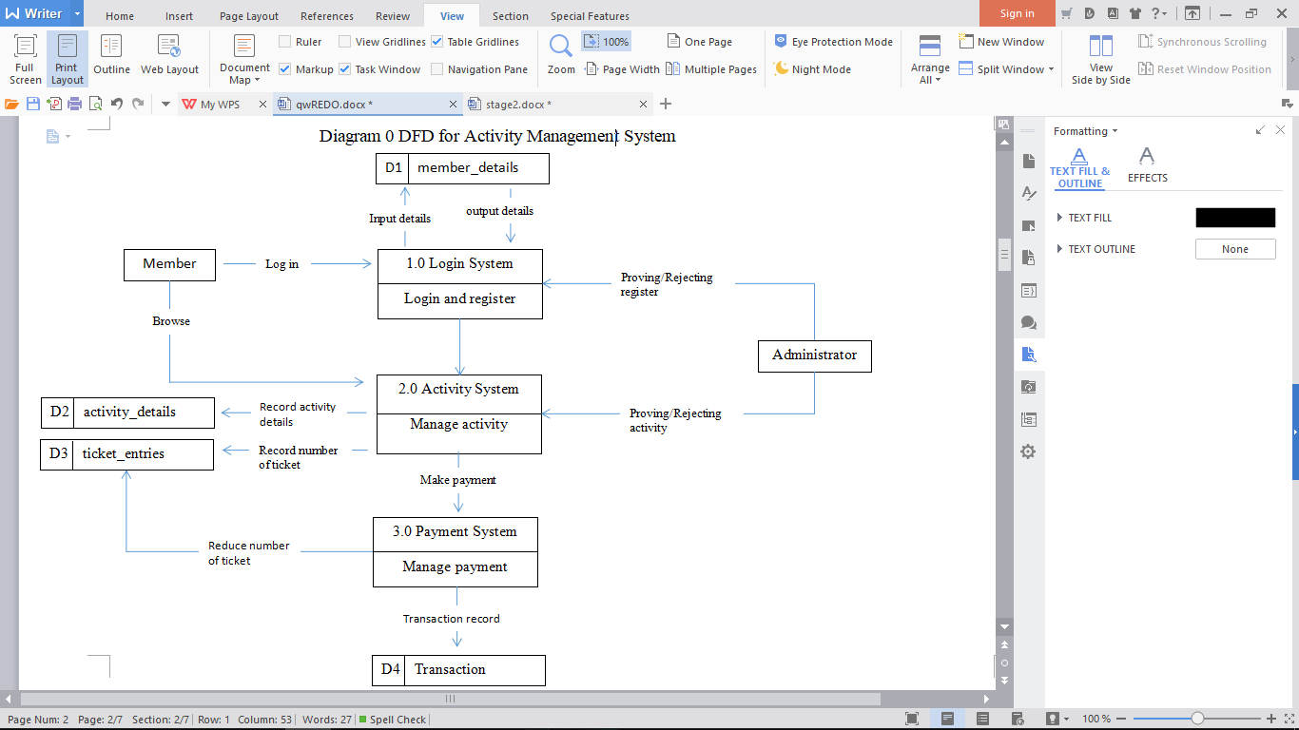

**12.3 DFD Diagram 1**

**Diagram 1 DFD Login System**

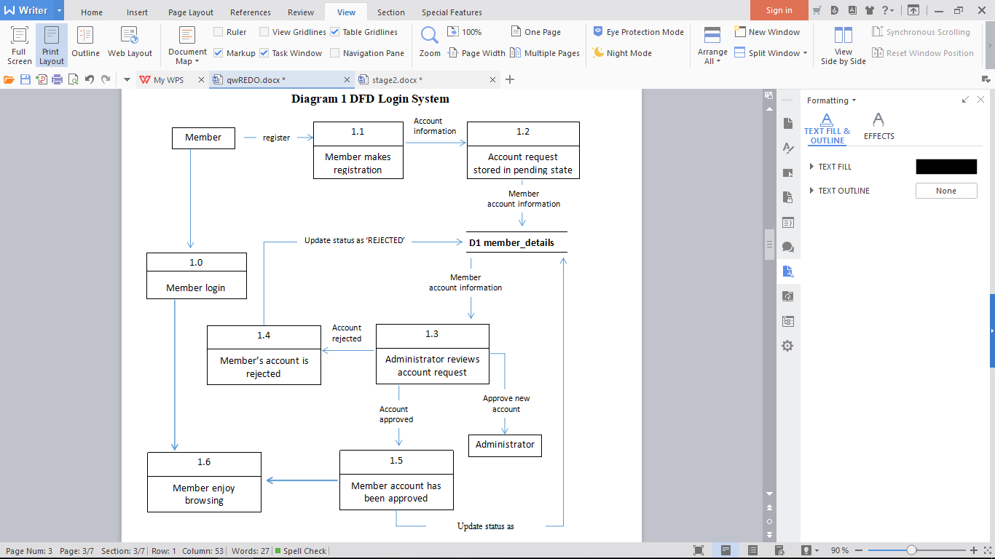

**Diagram 1 DFD Activity System**

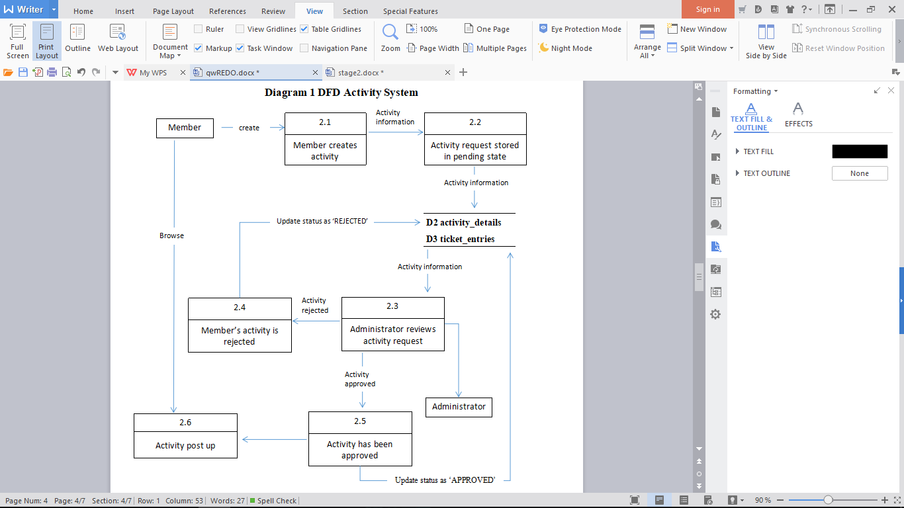

**Diagram 1 DFD Payment System**

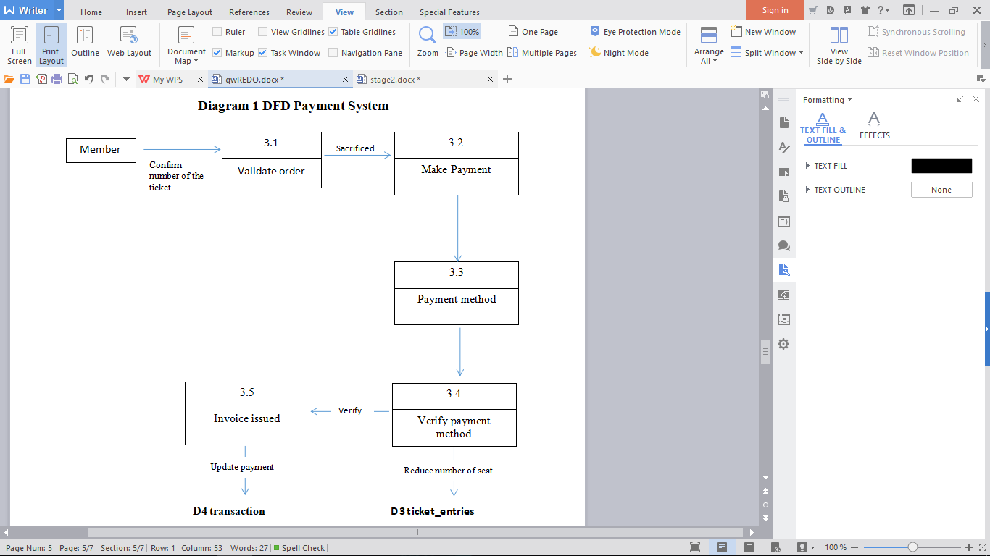

**13. Entity Relationship Diagram**

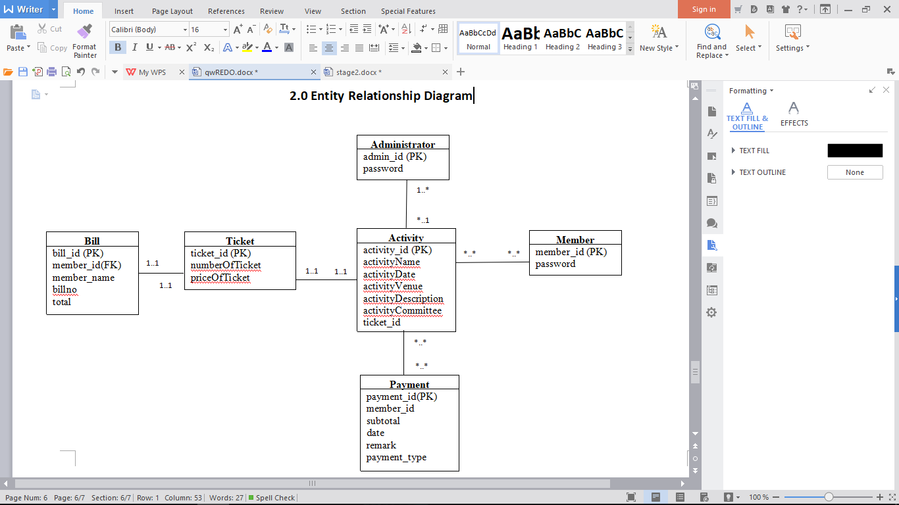

**14.** **Class Diagram**

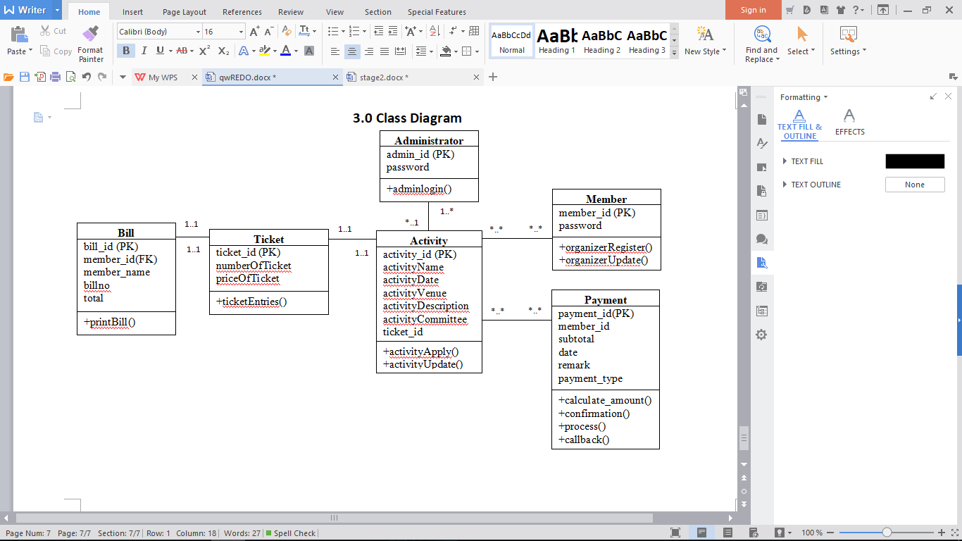

**15.0 Use case diagram**

**15.1 Login System**

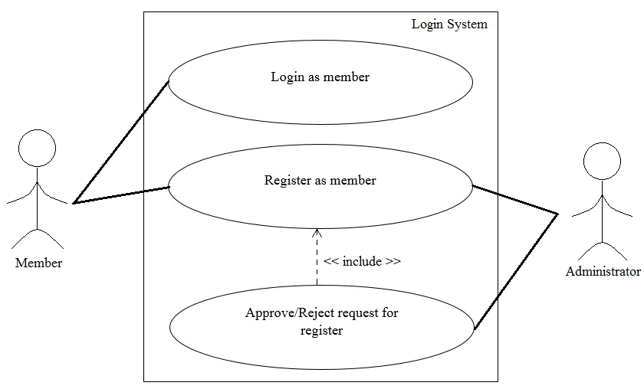

**15.2 Activity System**

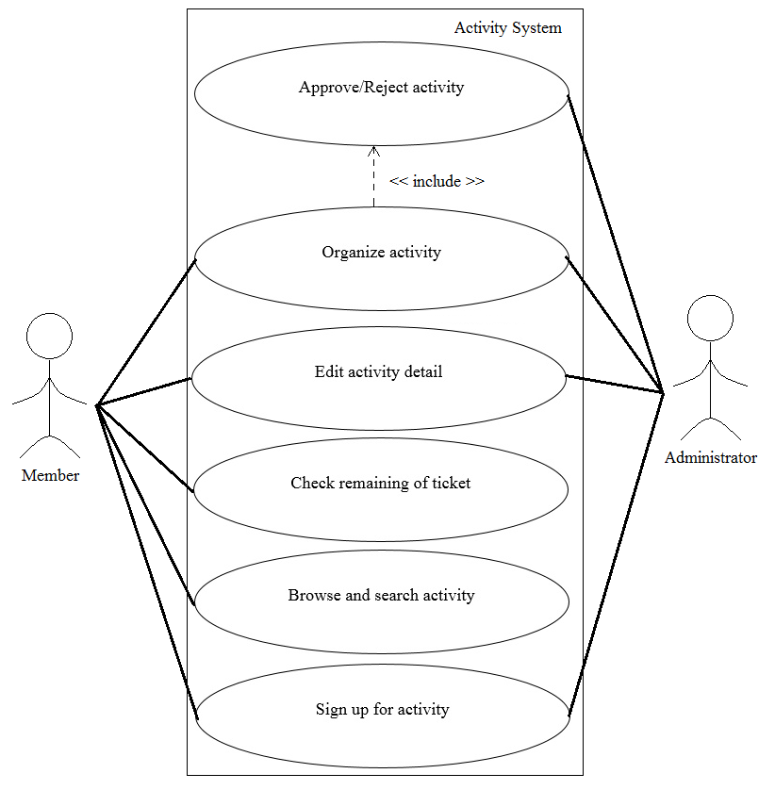

**15.3Payment System**

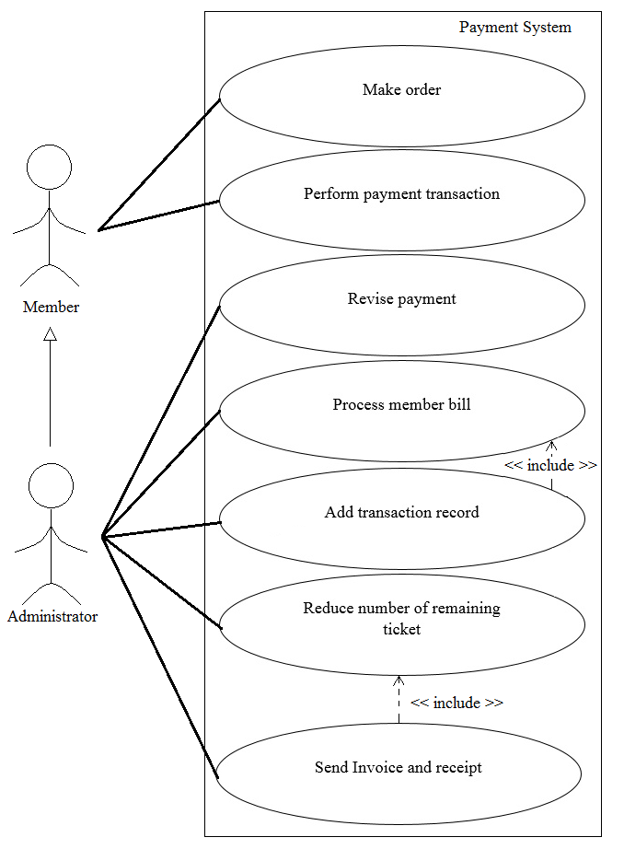

**16.0 Use case description**

**16.1 Login System**

|  |  |  |
| --- | --- | --- |
| **Use case: Login as member (Login System)** | | |
|
| Overview: This case describes how the member log in. | | |
|
| Pre-conditions:   1. Network connection with server required. | | |
|
| Post conditions:   1. Successful condition  * Member log in successfully. | | |
|
|
| Event | | Response |
| 1 | User browse the webpage system. | * + - * Display main page UI. |
| 2 | User select Login. | * + - * Display log in page UI. |
| 3 | User insert username and password required. | - |
| 4 | User select Login button. | * + - * Perform information validation.       * Display message “<Username> log in successfully.”       * Display member UI. |
| 5 | User login success. | * + - * User login as member. |
| Extensions | | |
| 4 | Invalid username and password. | * + - * Reject the request.       * Display error message.       * Re-enter information required. |

|  |  |  |
| --- | --- | --- |
| **Use case: Register as member (Login System)** | | |
|
| Overview: This case describes how the user register as member. | | |
|
| Pre-conditions:   1. Network connection with server required. | | |
|
| Post conditions:   1. Successful condition  * Member register had successfully. | | |
|
|
| Event | | Response |
| 1 | User browse the webpage system. | * + - * Display main page UI. |
| 2 | User select register. | * + - * Display register UI. |
| 3 | User insert username and password. | - |
| 4 | User select confirm button. | * + - * Checking contain same information with database.       * Display message “Thank you for register, please wait for administrator to approve this registration. |
| 5 | Administrator select view register. | * + - * Display register request list. |
| 6 | Administrator select approve registration | * + - * Insert member register information into member database.       * Display message registration approve had successfully. |
| 7 | User select check registration process. | * + - * Display message “Register successfully.” |
| 8 | User register success. | * + - * User register as member successfully. |
| Extensions | | |
| 4 | Same information detected. | * + - * Reject the request.       * Display error message.       * Re-enter information required. |
| 7 | Administrator select reject. | * + - * Display message “Register rejected.” |

**16.2 Activity System**

|  |  |  |
| --- | --- | --- |
| **Use case: Organize activity (Activity System)** | | |
|
| Overview: This case describes how the member organize activity. | | |
|
| Pre-conditions:   1. Network connection with server required. 2. Member login required. | | |
|
| Post conditions:   1. Successful condition  * Member organize activity successfully. | | |
|
|
| Event | | Response |
| 1 | Member login to webpage. | * + - * Perform account validation.       * Display main page UI. |
| 2 | Member select activity. | * + - * Display activity page with many options. |
| 3 | Member select organize activity. | * + - * Display organize activity UI and required insert activity detail. |
| 4 | Member insert activity detail. | - |
| 5 | Member select confirm. | * + - * Sending information to administrator.       * Display message “Please wait for admin to approve this request.” |
| 5 | Administrator select activity organize list. | * + - * Display request of activity organize list. |
| 6 | Administrator select approve. | * + - * Insert activity information into Activity and ticket entries database.       * Display message “Activity approved” |
| 7 | Member select view request status. | * + - * Display request list and status. |
| 8 | Member select activity. | * + - * Display message “Request approved.” |
| Extensions | | |
| 1 | Invalid account. | * + - * Display message “Please enter correct user Username/Password.”       * Clear the password text field. |
| 8 | Administrator select reject. | * + - * Display message “Request rejected.” |

|  |  |  |
| --- | --- | --- |
| **Use case: Edit activity (Activity System)** | | |
|
| Overview: This case describes how the member edit activity. | | |
|
| Pre-conditions:   1. Network connection with server required. 2. Member login required. 3. Activity had been organized. | | |
|
| Post conditions:   1. Successful condition  * Member edit activity successfully. | | |
|
|
| Event | | Response |
| 1 | Member login to webpage. | * + - * Perform account validation.       * Display main page UI. |
| 2 | Member select activity. | * + - * Display activity page with many options. |
| 3 | Member select activity from list. | * + - * Display the list of activity that organized. |
| 4 | Member select edit activity. | * + - * Receive activity detail from activity and ticket entries database.       * Display activity detail in text field. |
| 5 | Member edit the activity detail. | - |
| 6 | Member select confirm. | * + - * Update activity detail to activity and ticket entries database.       * Display message “Edit successfully.” |
| 7 | Member edit activity success. | - |
| Extensions | | |
| 1 | Invalid account. | * + - * Display message “Incorrect user ID/Password, please enter correct user ID/Password.”       * Clear the password text field. |

|  |  |  |
| --- | --- | --- |
| **Use case: Check remaining of ticket (Activity System)** | | |
|
| Overview: This case describes how the member check the remaining of ticket. | | |
|
| Pre-conditions:   1. Network connection with server required. 2. Member login required. 3. Activity had been organized. | | |
|
| Post conditions:   1. Successful condition  * Member check remaining of ticket successfully. | | |
|
|
| Event | | Response |
| 1 | Member login to webpage. | * + - * Perform account validation.       * Display main page UI. |
| 2 | Member select activity. | * + - * Display activity page with many options. |
| 3 | Member select activity from list. | * + - * Display the list of activity that had organized. |
| 4 | Member select ticket. | * + - * Display the remaining of ticket and other option. |
| 5 | Member check remaining of ticket successfully. | - |
| Extensions | | |
| 1 | Invalid account. | * + - * Display message “Incorrect user ID/Password, please enter correct user ID/Password.”       * Clear the password text field. |

|  |  |  |
| --- | --- | --- |
| **Use case: Browse and search activity (Activity System)** | | |
|
| Overview: This case describes how the member browse and search for activity. | | |
|
| Pre-conditions:   1. Network connection with server required. 2. Member login required. | | |
|
| Post conditions:   1. Successful condition  * Member browse and search activity successfully. | | |
|
|
| Event | | Response |
| 1 | Member login to webpage. | * + - * Perform account validation.       * Display main page UI. |
| 2 | Member insert activity name or type. | * + - * Display some similar activity under search bar. |
| 3 | Member select search. | * + - * Display all similar activity list. |
| 4 | Member browse and search activity had successfully. | - |
| Extensions | | |
| 1 | Invalid account. | * + - * Display message “Incorrect user ID/Password, please enter correct user ID/Password.”       * Clear the password text field. |
| 3 | Member insert name or type that not related at all. | * + - * Display message “The related activity is not found.” |

|  |  |  |
| --- | --- | --- |
| **Use case: Sign up for activity (Activity System)** | | |
|
| Overview: This case describes how the member sign up for activity. | | |
|
| Pre-conditions:   1. Network connection with server required. 2. Member login required. | | |
|
| Post conditions:   1. Successful condition  * Display make order page. | | |
|
|
| Event | | Response |
| 1 | Member login to webpage. | * + - * Perform account validation.       * Display main page UI. |
| 2 | Member select activity. | * + - * Display activity detail page and some option. |
| 3 | Member select sign up. | * + - * Display text field required insert personal information. |
| 4 | Member insert information. | - |
| 5 | Member select confirm. | * + - * Checking information missing.       * Display payment page. |
| Extensions | | |
| 1 | Invalid account. | * + - * Display message “Incorrect user ID/Password, please enter correct user ID/Password.”       * Clear the password text field. |
| 5 | User information missing | * Reject request * Display error message * Display message “Some information is missing, please fill the information.” |

**16.3 Payment System**

|  |  |  |
| --- | --- | --- |
| **Use case: Make order (Payment System)** | | |
|
| Overview: This case describes how the member make order to continue sign up progress. | | |
|
| Pre-conditions:   1. Network connection with server required. 2. Member login required. 3. Member had insert information and accepted by system. | | |
|
| Post conditions:   1. Successful condition  * Display perform payment transaction page. | | |
|
|
| Event | | Response |
| 1 | Member select confirm in sign up page. | * + - * Display make order UI. |
| 2 | Member select number of ticket for purchase. | * + - * Checking the amount of remaining ticket is more than ordering ticket.       * Display confirm button. |
| 3 | Member select confirm. | * + - * Display perform payment transaction page. |
| Extensions | | |
| 2 | Amount of remaining ticket is less than ordering ticket. | * Reject request * Display message “The remaining ticket is <amount of remaining ticket> which is not enough for your order, please re-select the number of ticket you want to purchase.” * Re-select required. |

|  |  |  |
| --- | --- | --- |
| **Use case: Perform payment transaction (Payment System)** | | |
|
| Overview: This case describes how the member perform payment transaction to complete sign up. | | |
|
| Pre-conditions:   1. Network connection with server required. 2. Member login required. 3. Member had make order successfully. | | |
|
| Post conditions:   1. Successful condition  * Member payment successfully. * Member sign up for activity successfully. | | |
|
|
| Event | | Response |
| 1 | Member select confirm in make order page. | * + - * Display payment UI. |
| 2 | Member select payment method. | * + - * Display text field for require insert payment information. |
| 3 | Member insert payment information. | - |
| 4 | Member select confirm. | * + - * Checking payment transaction.       * Payment transaction accepted.       * Send transaction into transaction database. |
| 5 | Member payment transaction successfully. | - |
| 6 | Member sign up for activity successfully. | - |
| Extensions | | |
| 4 | Invalidate payment information detected. | * Reject request * Display error message * Display message “Please re-enter the information to continue the payment.” |

|  |  |  |
| --- | --- | --- |
| **Use case: Revise payment (Payment System)** | | |
|
| Overview: This case describes how the administrator revise the payment. | | |
|
| Pre-conditions:   1. Network connection with server required. 2. Administrator login required. | | |
|
| Post conditions:   1. Successful condition  * Order revised successfully. | | |
|
|
| Event | | Response |
| 1 | Administrator login to webpage. | * + - * Perform account validation.       * Display administrator page UI. |
| 2 | Administrator select payment system. | * + - * Display payment system UI. |
| 3 | Administrator select view sales order. | * + - * Receive data from transaction database.       * Display sales order list. |
| 4 | Administrator select an order. | * + - * Display order detail. |
| 5 | Administrator edit the sales order information. | - |
| 6 | Administrator select confirm | * + - * Perform details validation.       * Update sales order information into transaction database.       * Display message “Sales order revise successfully”. |
| 7 | Administrator revise the order successfully. | - |
| Extensions | | |
| 1 | Invalid account. | * + - * Display message “Incorrect user ID/Password, please enter correct user ID/Password.”       * Clear the password text field. |
| 6 | Validation failed | * + - * Reject request.       * Display error message. |

|  |  |  |
| --- | --- | --- |
| **Use case: Process member bill (Payment System)** | | |
|
| Overview: This case describes how the administrator process member bill. | | |
|
| Pre-conditions:   1. Network connection with server required. 2. Administrator login required. | | |
|
| Post conditions:   1. Successful condition  * Administrator process member bill successfully. | | |
|
|
| Event | | Response |
| 1 | Administrator login to webpage. | * + - * Perform account validation.       * Display administrator page UI. |
| 2 | Administrator select payment system. | * + - * Display payment system UI. |
| 3 | Administrator select view sales order. | * + - * Receive data from transaction database.       * Display sales order list. |
| 4 | Administrator select an order. | * + - * Display order detail. |
| 5 | Administrator select process member order. | * + - * Process member bill.       * Add transaction record.       * Insert into transaction database.       * Display message “Process member bill successfully.” |
| 6 | Administrator process member bill successfully. | - |
| Extensions | | |
| 1 | Invalid account. | * + - * Display message “Incorrect user ID/Password, please enter correct user ID/Password.”       * Clear the password text field. |

|  |  |  |
| --- | --- | --- |
| **Use case: Send Invoice and receipt (Payment System)** | | |
|
| Overview: This case describes how the invoice and recipe work. | | |
|
| Pre-conditions:   1. Network connection with server required. 2. Administrator had process member bill. | | |
|
| Post conditions:   1. Successful condition  * Reduce seat from ticket entries database had successfully. * Invoice and receipt has successfully send. | | |
|
|
| Event | | Response |
| 1 | Transaction record complete detected. | * Reduce seat from ticket entries database. * Receive bill from database. * Send Invoice to member. * Send receipt to member. |
| 2 | Reduce seat from ticket entries database successfully. | - |
| 3 | Invoice successfully send to user. | - |
| 4 | Receipt successfully send to user. | - |
| Extensions | | |
| - | - | - |

**16.0** [**Activity**](https://r.search.yahoo.com/_ylt=Awr9LvCacwZbE_QAuMYPQgx.;_ylu=X3oDMTByb2lvbXVuBGNvbG8DZ3ExBHBvcwMxBHZ0aWQDBHNlYwNzcg--/RV=2/RE=1527178266/RO=10/RU=https%3a%2f%2fen.wikipedia.org%2fwiki%2fActivity_diagram/RK=2/RS=DKVTDHKbDpfRuEevHar9A.wJHmo-) **Diagram**

**17.1 Login System**

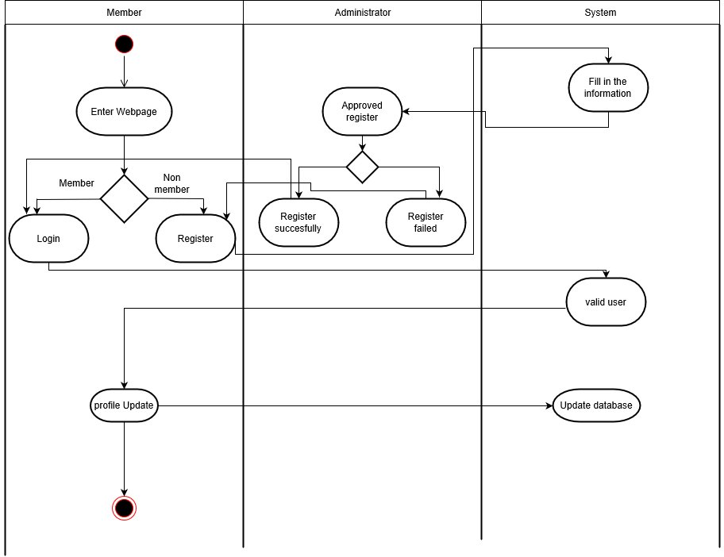

**17.2 Activity System**

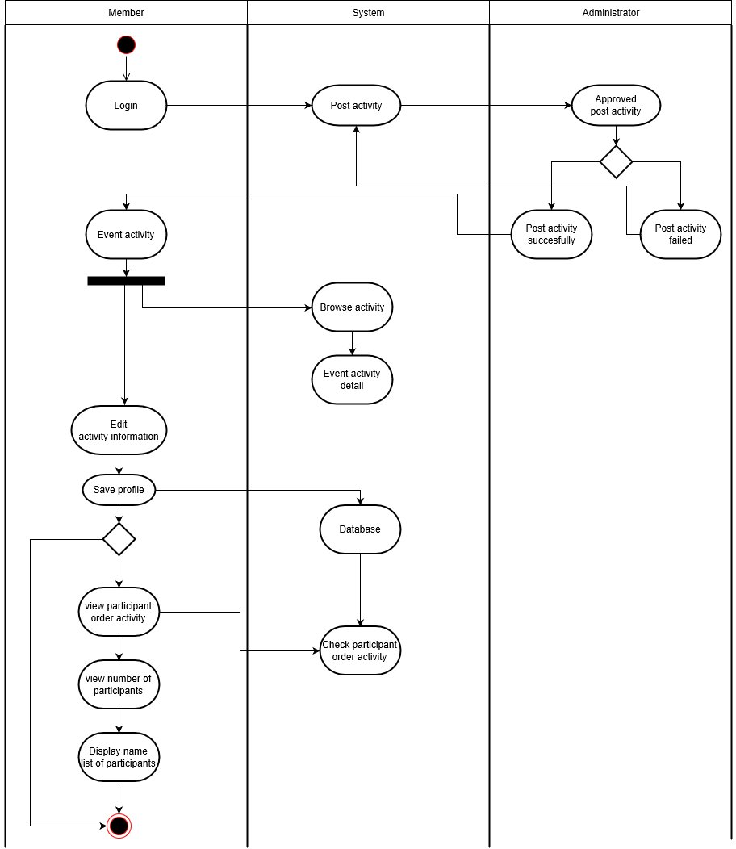

**17.3 Payment System**

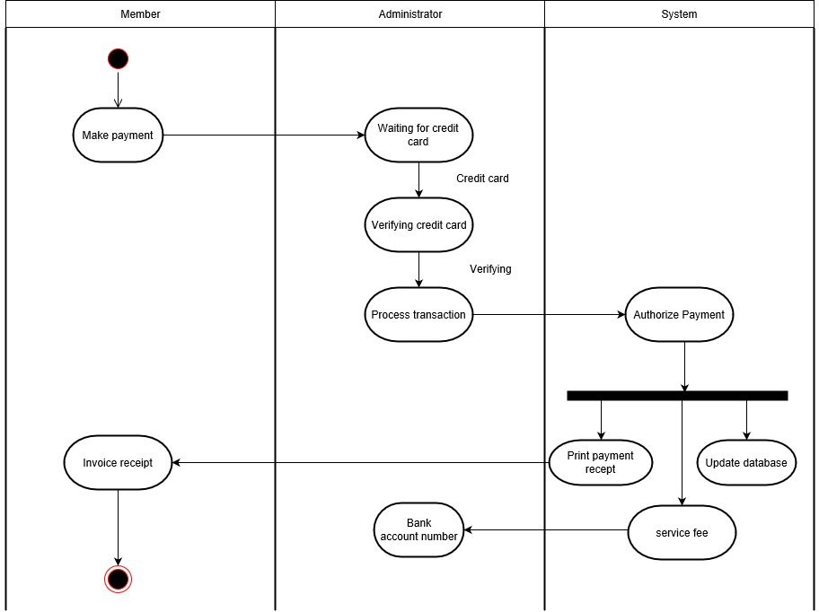

**18.0 Sequence diagram**

**18.1 Login System**

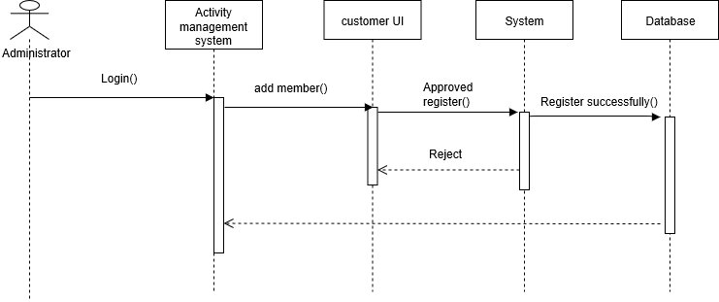

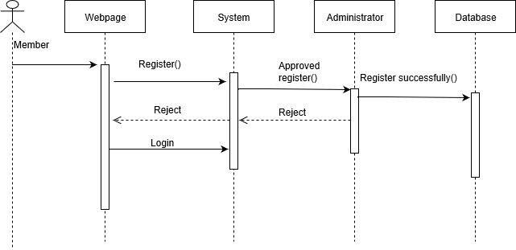

**18.2 Activity System**

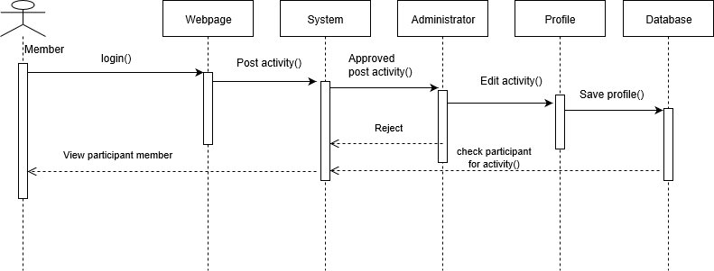

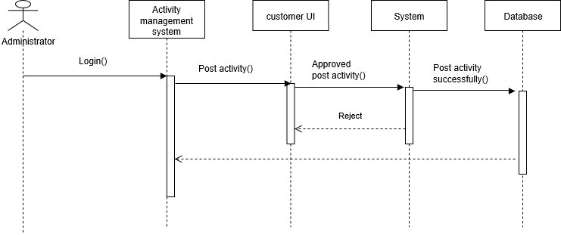

**18.3 Payment System**

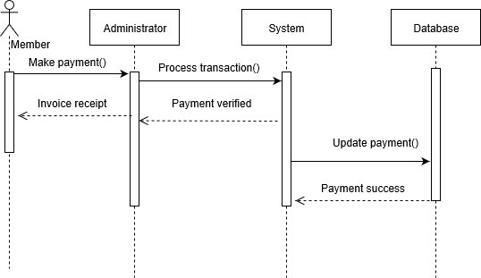

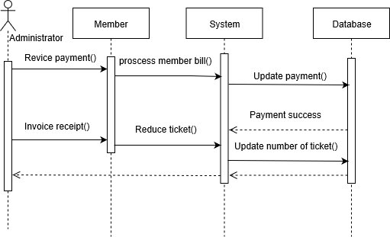

**19. System Catalog**

This section will describe the role of each database field in this system.

1. ams

|  |  |  |  |
| --- | --- | --- | --- |
| No. | Field | Type | Extra |
| I. | userID (primary key) | VARCHAR (20) |  |
| II. | password | VARCHAR (2000) |  |
| III. | fullname | VARCHAR (20) |  |

1. event

|  |  |  |  |
| --- | --- | --- | --- |
| No. | Field | Type | Extra |
| I. | caid (primary key) | INT (3) | Unsignes zerofill |
| II. | causer | VARCHAR (20) |  |
| III. | caname | VARCHAR (50) |  |
| IV. | cadate | VARCHAR (50) |  |
| V. | cavenue | VARCHAR (200) |  |
| VI. | cacategory | VARCHAR (20) |  |
| VII. | cadescription | VARCHAR (500) |  |
| VIII. | cacommittee | VARCHAR (200) |  |
| IX. | catime | VARCHAR (50) |  |
| X. | status | VARCHAR (20) |  |

1. request

|  |  |  |  |
| --- | --- | --- | --- |
| No. | Field | Type | Extra |
| I. | rid (primary key) | VARCHAR (4) |  |
| II. | ruser | VARCHAR (20) |  |
| III. | rname | VARCHAR (50) |  |
| IV. | rdate | VARCHAR (50) |  |
| V. | rvenue | VARCHAR (200) |  |
| VI. | rcategory | VARCHAR (20) |  |
| VII. | rtime | VARCHAR (50) |  |
| VIII. | rstatus | VARCHAR (5) |  |

1. fb

|  |  |  |  |
| --- | --- | --- | --- |
| No. | Field | Type | Extra |
| I. | fbid (primary key) | INT (3) |  |
| II. | fbuser | VARCHAR (20) |  |
| III. | fbcomment | VARCHAR (2000) |  |
| IV. | fbtime | VARCHAR (50) |  |

**20.0 User Guide**

Figure 1.0: Index page

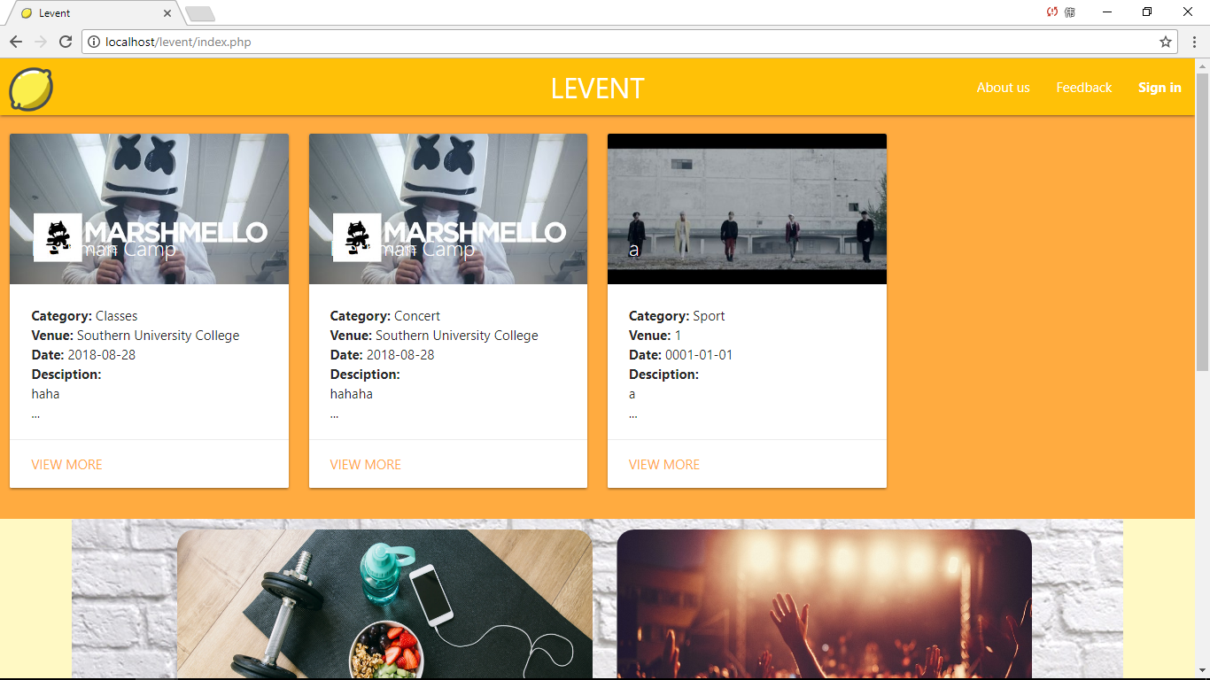

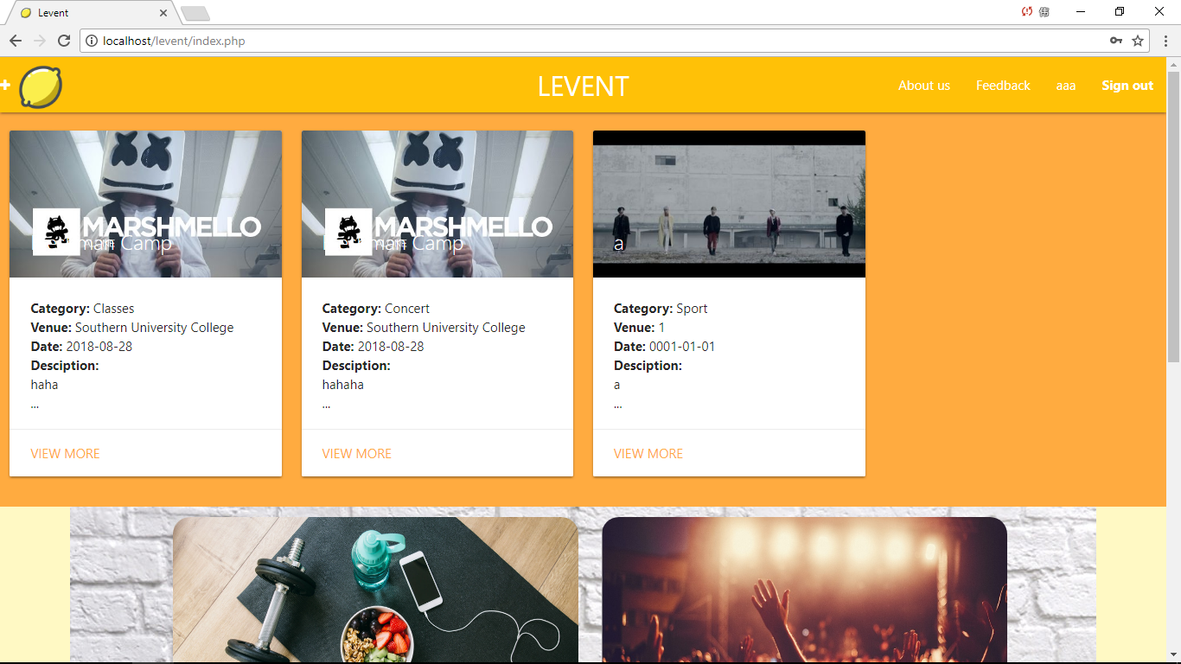

Figure 1.0 is the index page for the Activity Management System. Navigation bar have three button when haven sign in. After sign in,the word ‘sign in’ will change to ‘sign out’ and add a button of the username. At the left of navigation bar,it have a ‘add’ icon after sign in.

The index page also show the category of activity.

20.1: Login page

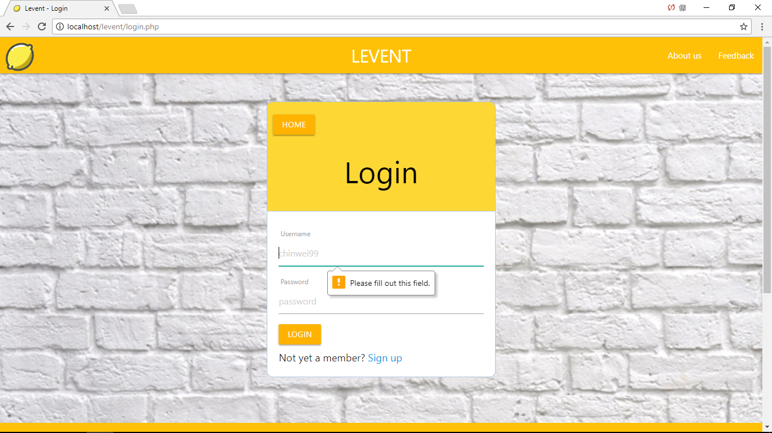

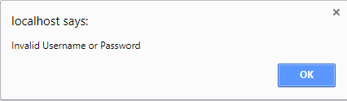

Figure 2.0 is the login page for the Activity Management System. Without entering the username or password,the are not allow to enter to the system and it will pop out a notification on top of the box to announce invalid username and password.

20.2: Register page

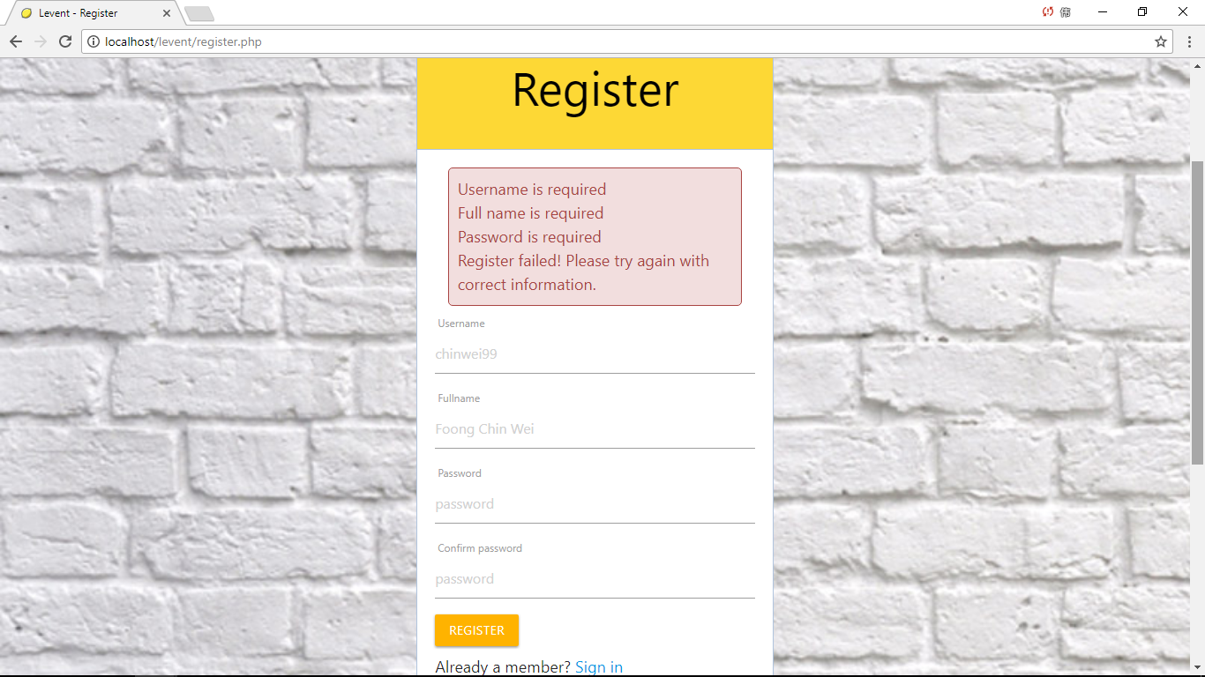

Figure 3.0 is the login page for the Activity Management System. User have to enter information and press ‘register’ button to register and bring user to the login page.If user not enter either one information,it will pop out the message to show what user miss to enter.

20.3: Create activity page

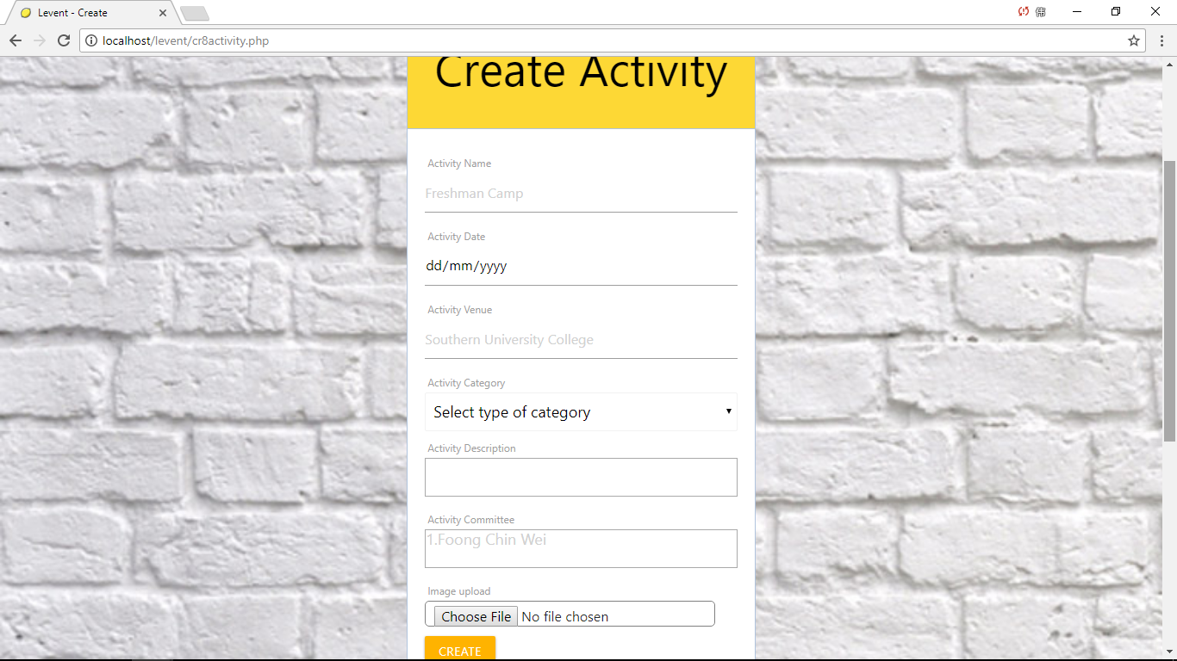

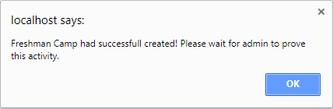

Figure 4.0 show the create activity page.After press the ‘add’ icon on the index page,it will bring member to this page.Member can insert the information and picture that will show on the index page after proving by the administrator.

20.4: Admin page

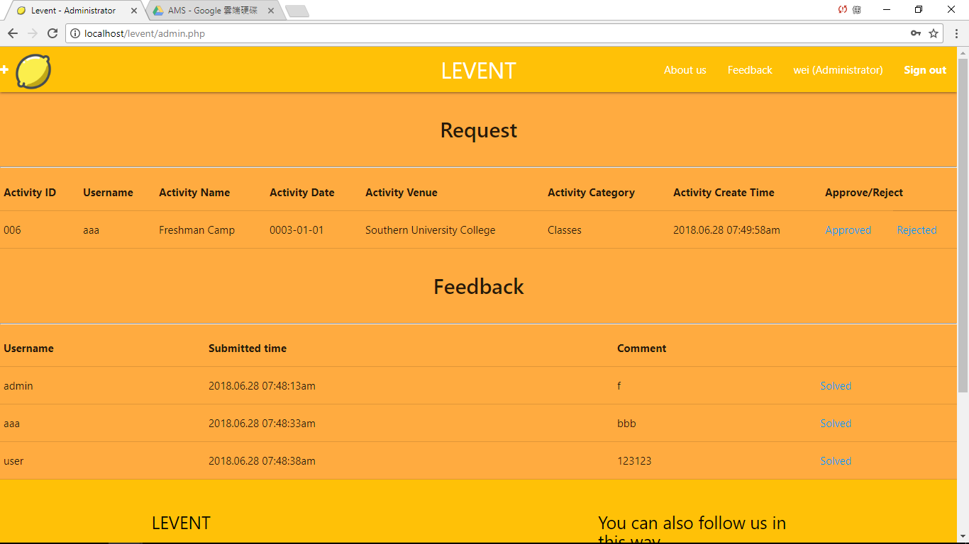

Figure 5.0 show the admin page.When administrator enter their id,it will automatic bring administrator to this admin page.The page show the activity information insert by member and administrator can approve or reject it.If the administrator approved the activity,the index page will show the latest activity that just proved by administrator.If the administrator rejected the activity,the request will disappear and won’t show the activity on the index page.

Besides that,it also show the feedback that user or member give,administrator can press the solved button to disappear the feedback when the problem was solved.

20.5: Category page

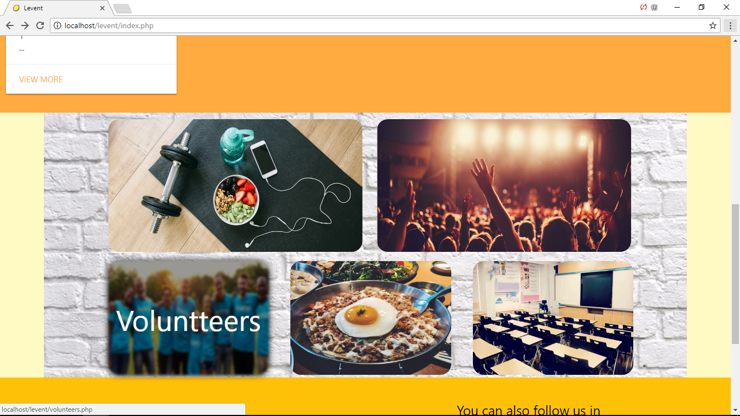

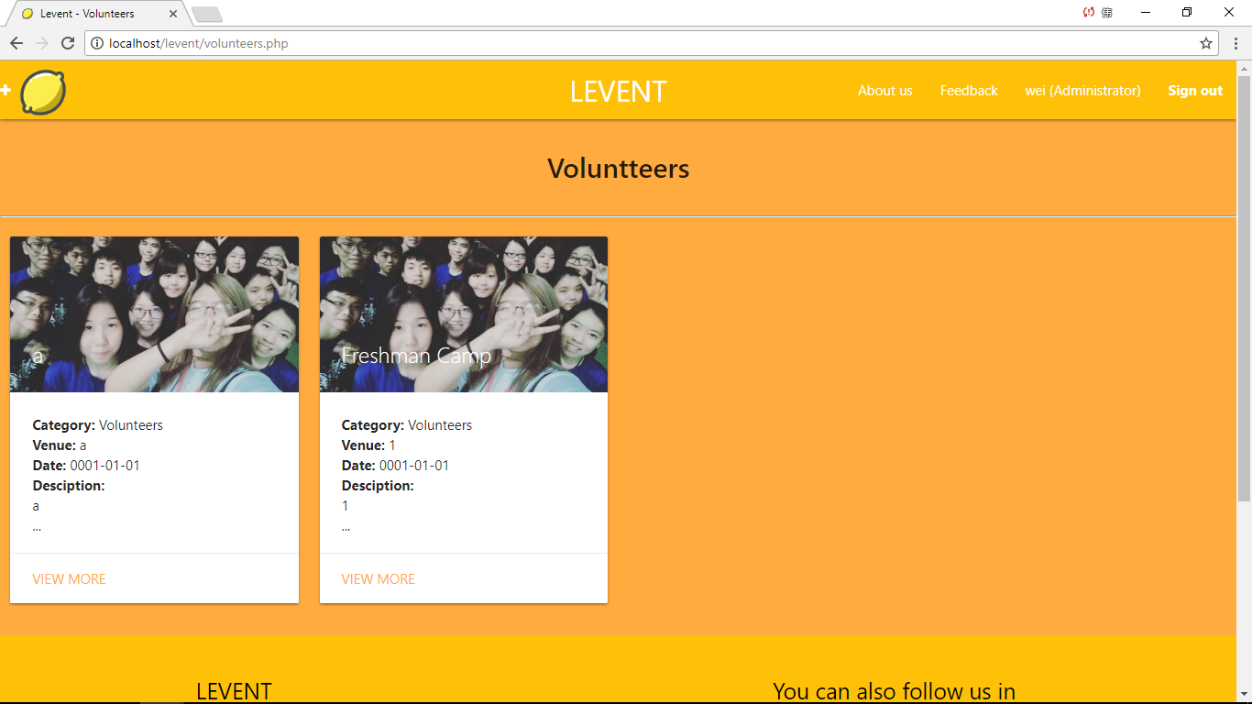

Figure 6.0 show the category page.When user press the category card on index page,it will bring to the category page that activity belong to.Inside category page,it will show the activity that member choose the category when create activity.

20.6: Feedback page

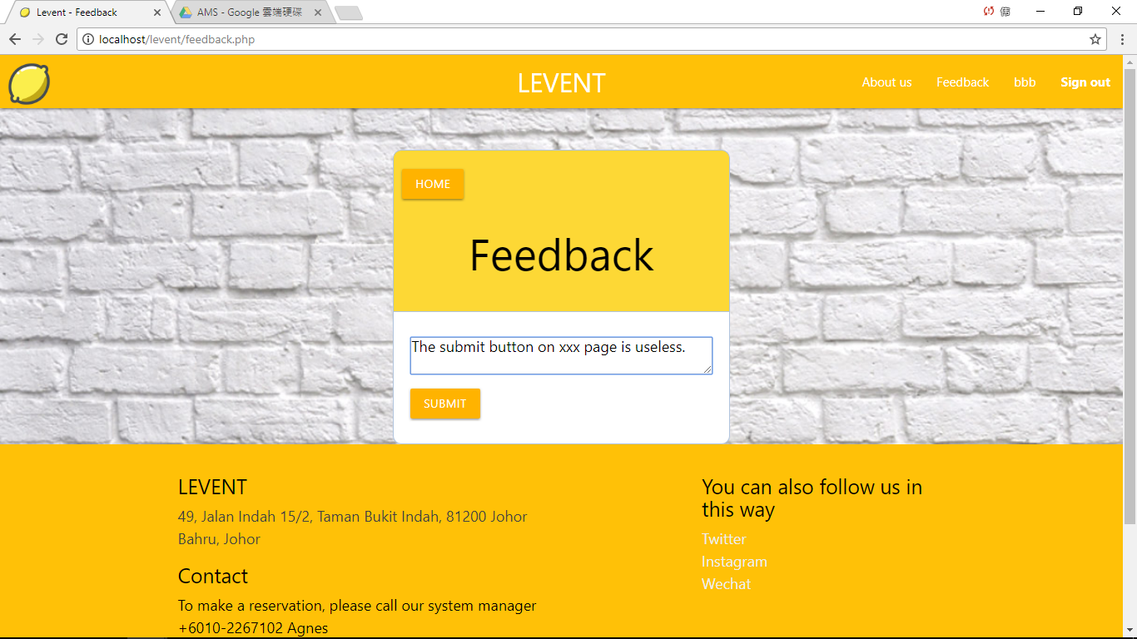

Figure 7.0 show the feedback page.The user or member can enter their feedback and the feedback will send to the admin page to let admin solve.

20.7: About Us page

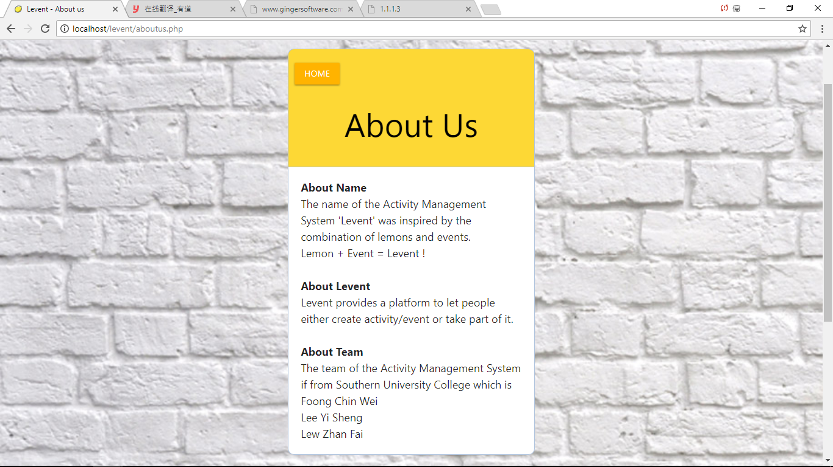

Figure 8.0 show the about use page.It show the information of the team,the introduction and inspiration of the name.

21. References

(Iterative Model,2017)  
-<https://www.testingexcellence.com/iterative-model/>

(BIZZABO, 2018)-[www.bizzabo.com/](http://www.bizzabo.com/)

(HTML)- <https://searchmicroservices.techtarget.com/definition/HTML-Hypertext-Markup-Language>

(PHP) – <https://whatis.techtarget.com/definition/PHP-Hypertext-Preprocessor>

(MySQL) - <https://searchoracle.techtarget.com/definition/MySQL>

(Web service) - <https://searchmicroservices.techtarget.com/definition/Web-services-application-services>

# (RT Essentials,2005)-[https://www.smartsheet.com/how-use-smartsheet-it-ticketing-system](https://web.wechat.com/cgi-bin/mmwebwx-bin/webwxcheckurl?requrl=https%3A%2F%2Fwww.smartsheet.com%2Fhow-use-smartsheet-it-ticketing-system&skey=%40crypt_3666a7c3_d2d19170183d27315be94935b4989b6b&deviceid=e201808916894162&pass_ticket=3sw1kHFAjtu7s7o56Z5c5Lwoal7muKz3m%252BW3pWbhb9WM1%252F88C%252BwM44sPO7%252FxWy5F&opcode=2&scene=1&username=@e12365b9cbe236c65c9b7811d4756cc1400bc7b45802002efcdc50a8d8124e12) https://www.safaribooksonline.com/library/view/rt-essentials/0596006683/ch01.html https://www.safaribooksonline.com/library/view/rt-essentials/0596006683/[https://www.smartsheet.com/how-use-smartsheet-it-ticketing-system](https://web.wechat.com/cgi-bin/mmwebwx-bin/webwxcheckurl?requrl=https%3A%2F%2Fwww.smartsheet.com%2Fhow-use-smartsheet-it-ticketing-system&skey=%40crypt_3666a7c3_d2d19170183d27315be94935b4989b6b&deviceid=e201808916894162&pass_ticket=3sw1kHFAjtu7s7o56Z5c5Lwoal7muKz3m%252BW3pWbhb9WM1%252F88C%252BwM44sPO7%252FxWy5F&opcode=2&scene=1&username=@e12365b9cbe236c65c9b7811d4756cc1400bc7b45802002efcdc50a8d8124e12) https://www.safaribooksonline.com/library/view/rt-essentials/0596006683/ch01.html https://www.safaribooksonline.com/library/view/rt-essentials/0596006683/[https://www.smartsheet.com/how-use-smartsheet-it-ticketing-system](https://web.wechat.com/cgi-bin/mmwebwx-bin/webwxcheckurl?requrl=https%3A%2F%2Fwww.smartsheet.com%2Fhow-use-smartsheet-it-ticketing-system&skey=%40crypt_3666a7c3_d2d19170183d27315be94935b4989b6b&deviceid=e201808916894162&pass_ticket=3sw1kHFAjtu7s7o56Z5c5Lwoal7muKz3m%252BW3pWbhb9WM1%252F88C%252BwM44sPO7%252FxWy5F&opcode=2&scene=1&username=@e12365b9cbe236c65c9b7811d4756cc1400bc7b45802002efcdc50a8d8124e12) https://www.safaribooksonline.com/library/view/rt-essentials/0596006683/ch01.html https://www.safaribooksonline.com/library/view/rt-essentials/0596006683[https://www.smartsheet.com/how-use-smartsheet-it-ticketing-system](https://web.wechat.com/cgi-bin/mmwebwx-bin/webwxcheckurl?requrl=https%3A%2F%2Fwww.smartsheet.com%2Fhow-use-smartsheet-it-ticketing-system&skey=%40crypt_3666a7c3_d2d19170183d27315be94935b4989b6b&deviceid=e201808916894162&pass_ticket=3sw1kHFAjtu7s7o56Z5c5Lwoal7muKz3m%252BW3pWbhb9WM1%252F88C%252BwM44sPO7%252FxWy5F&opcode=2&scene=1&username=@e12365b9cbe236c65c9b7811d4756cc1400bc7b45802002efcdc50a8d8124e12) https://www.safaribooksonline.com/library/view/rt-essentials/0596006683/ch01.html https://www.safaribooksonline.com/library/view/rt-essentials/0596006683[https://www.smartsheet.com/how-use-smartsheet-it-ticketing-system](https://web.wechat.com/cgi-bin/mmwebwx-bin/webwxcheckurl?requrl=https%3A%2F%2Fwww.smartsheet.com%2Fhow-use-smartsheet-it-ticketing-system&skey=%40crypt_3666a7c3_d2d19170183d27315be94935b4989b6b&deviceid=e201808916894162&pass_ticket=3sw1kHFAjtu7s7o56Z5c5Lwoal7muKz3m%252BW3pWbhb9WM1%252F88C%252BwM44sPO7%252FxWy5F&opcode=2&scene=1&username=@e12365b9cbe236c65c9b7811d4756cc1400bc7b45802002efcdc50a8d8124e12) https://www.safaribooksonline.com/library/view/rt-essentials/0596006683/ch01.html https://www.safaribooksonline.com/library/view/rt-essentials/0596006683[https://www.smartsheet.com/how-use-smartsheet-it-ticketing-system](https://web.wechat.com/cgi-bin/mmwebwx-bin/webwxcheckurl?requrl=https%3A%2F%2Fwww.smartsheet.com%2Fhow-use-smartsheet-it-ticketing-system&skey=%40crypt_3666a7c3_d2d19170183d27315be94935b4989b6b&deviceid=e201808916894162&pass_ticket=3sw1kHFAjtu7s7o56Z5c5Lwoal7muKz3m%252BW3pWbhb9WM1%252F88C%252BwM44sPO7%252FxWy5F&opcode=2&scene=1&username=@e12365b9cbe236c65c9b7811d4756cc1400bc7b45802002efcdc50a8d8124e12) https://www.safaribooksonline.com/library/view/rt-essentials/0596006683/ch01.html [https://www.safaribooksonline.com/library/view/rt-essentials/0596006683https://www.smartsheet.com/how-use-smartsheet-it-ticketing-systemhttps://www.safaribooksonline.com/library/view/rt-essentials/0596006683/ch01.html](https://www.smartsheet.com/how-use-smartsheet-it-ticketing-system) -[https://www.safaribooksonline.com/library/view/rt-essentials/0596006683/ch01.htmlhttps://www.safaribooksonline.com/library/view/rt-essentials/0596006683/ch01.htmlhttps://www.safaribooksonline.com/library/view/rt-essentials/0596006683/ch01.htmlhttps://www.safaribooksonline.com/library/view/rt-essentials/0596006683/ch01.htmlhttps://www.safaribooksonline.com/library/view/rt-essentials/0596006683/ch01.htmlhttps://www.safaribooksonline.com/library/view/rt-essentials/0596006683/ch01.htmlhttps://www.safaribooksonline.com/library/view/rt-essentials/0596006683/ch01.htmlhttps://www.safaribooksonline.com/library/view/rt-essentials/0596006683/ch01.html](https://www.safaribooksonline.com/library/view/rt-essentials/0596006683/ch01.html) -https://www.safaribooksonline.com/library/view/rt-essentials/0596006683/